New Intake Tools 2026
for Conferences

Tools
- Digital Recording in English & Spanish 678-892-6163
- Online webform svdpgeorgia.org/_________
- Email address _______@svdpgeorgia.org
- Online email Inbox Outlook.live.com/mail/0/
- Dial-back Phone Number 678-250-xxxx
- GoTo mobile app Download from App Store

How Neighbors in Need Reach the Conference

- A Neighbor in Need calls the SVdP Georgia Statewide Assistance Line 678.892.6163.

- The Neighbor is asked to:
  - “press 1 for English”
  - “press 2 for Spanish”

- The Neighbor is asked to:
  - “enter your Zip Code”

- Callers in Zip Codes ________________ are directed to a recorded message for the Conference.
  - invited to call back on the last Monday of the month,
  - leave a message, or
  - go online to svdpgeorgia.org/________ to complete a webform and submit a request for assistance

- Voicemails are transmitted as Email to the Conference at _______@svdpgeorgia.org. Each email includes:
  - the caller’s phone number, captured by caller ID
  - a transcript of their voicemail
  - an audio file with their voicemail

- Webforms that are completed online at svdpgeorgia.org/_______ are emailed to ______@svdpgeorgia.org

Continued…

How Vincentians Retrieve Messages

- Intake volunteers retrieve messages by opening the webpage: https://outlook.live.com/mail/0/
  - Login: ----@svdpgeorgia.org
  - Password:
  - All Vincentians at the Conference will share the same credentials for Outlook. Do not change the password unless you are the Conference President or the President’s designee.

- Intake volunteers review the email messages and choose how to respond:
  - forward to a caseworker
  - move to a subfolder

How Vincentians Contact Neighbors

- Find the phone number in the Neighbor’s email message to call them back. The phone number is in the email Subject Line &/or inside the Body of the email on the completed Webform.

- Vincentians dial back / call out to the Neighbor from either
  - their personal mobile phone or
  - an SVdP Phone number for the Conference, 678-250-xxxx

- To dial back / call out from 678-250-xxxx, do the following:
  - Download the GoTo Mobile App
  - Login as ----@svdpgeorgia.org
  - Password: set by first user; select “Forgot Password” and follow prompts. All Vincentians at the Conference will share the same credentials for GoTo. Once the password is set by the first user, do not change the password unless you are the Conference President or the President’s designee.
  - Tap the black icon in the lower right corner
  - Dial the neighbor. Your caller ID will appear as “SVdP ----”

- If the Neighbor does not answer, leave a message with these instructions:
  - “Please ask for me, [YOUR NAME], when returning the call or leaving a message as many of our volunteers share this same line. Thank you!”

- Troubleshooting:
  - If GoTo has been ringing at unwanted times of the day, users should do the following:
    - Open GoToConnect to your device.
    - Tap the icon in the upper Left corner to open “Settings.”
    - Scroll to “Silence this device.”
    - Toggle on / green.
    - See the first screenshot below. This means that the caller will be forced to leave a voicemail first, which will appear in Outlook for the Intake team to review. We also have changed the setting on our backend. All neighbors who are calling caseworkers back also will leave a voicemail again. Your Intake volunteer will forward that message to the appropriate caseworker.
  - If you have begun to make a call and you see that another call is active: This is OK, and you can still initiate another call. Up to 250 simultaneous calls can be made from your number. See the second screenshot below. Simply begin to dial, and you will not disrupt the other call.

Examples (from St. Oliver Plunkett in Snellville)

Outlook Inbox for stoliver@svdpgeorgia.org with a webform from a Neighbor in Need

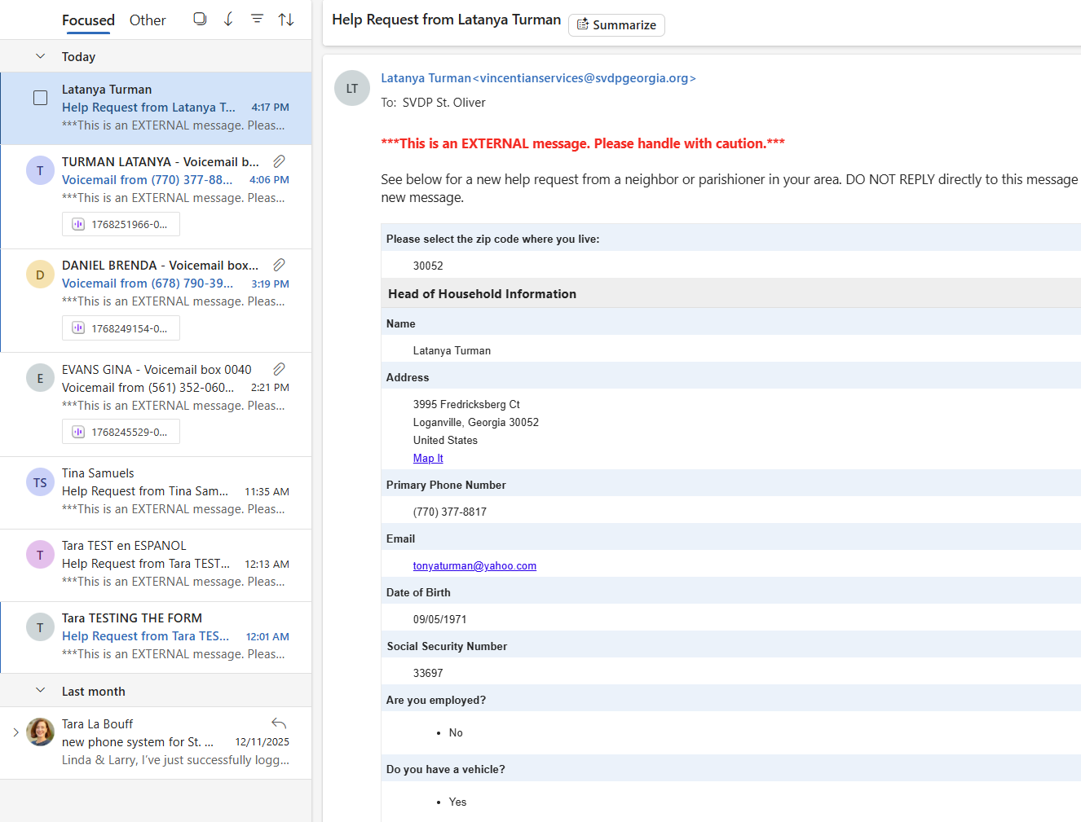
Voicemail transcribed as Email and sent to stoliver@svdpgeorgia.org

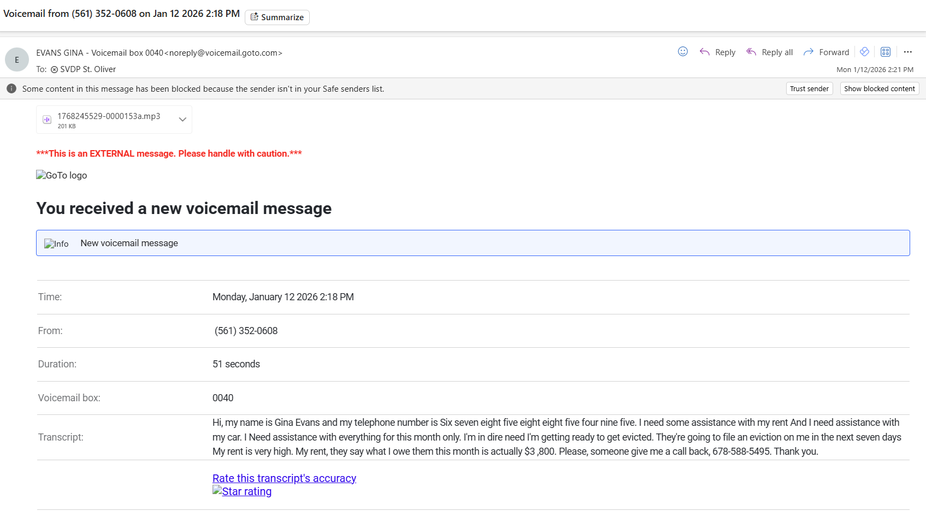
Outbound Message at 678-892-6163 for St. Oliver

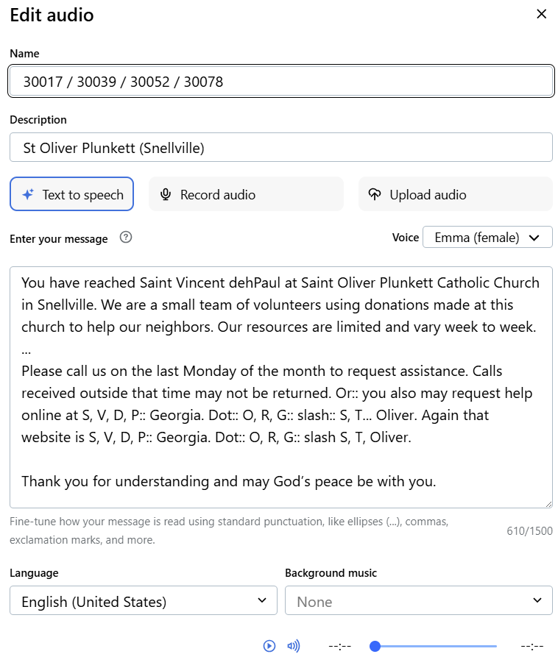

St. Oliver Conference online webform at svdpgeorgia.org/stoliver

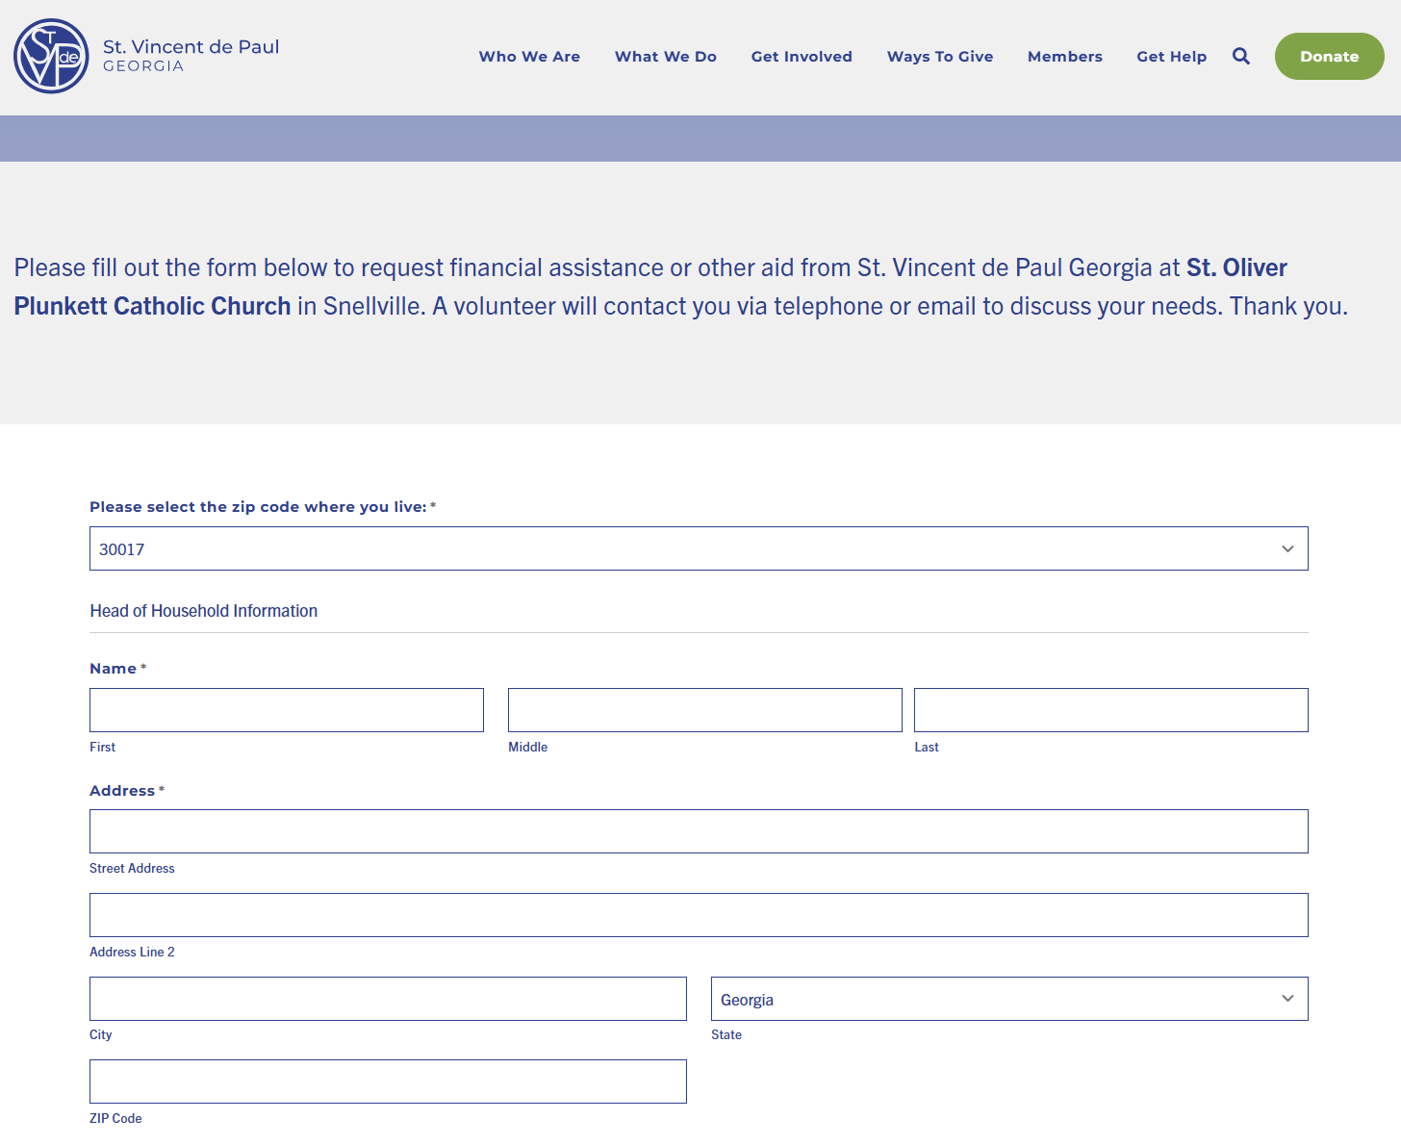

Continued…
