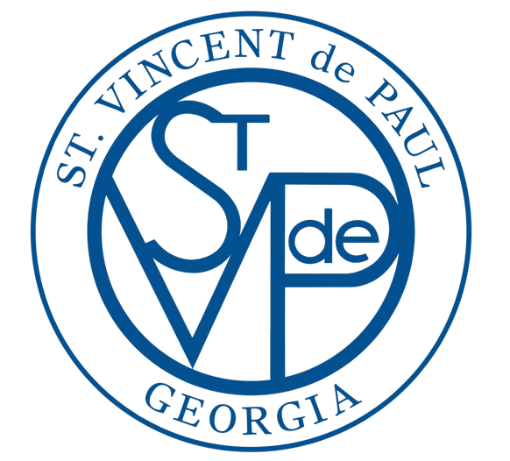
ST. VINCENT DE PAUL PARISH-BASED CHAPTERS (CONFERENCES)

ST. VINCENT DE PAUL CONFERENCES ARE THE HEARTBEAT OF WHAT WE DO.
Parish-based chapters, referred to as Conferences, are based out of dozens of parishes throughout the state, with each Conference serving an assigned territory within its local community. Neighbors who call our assistance line are directed to the appropriate Conference for intake. Conferences establish their own guidelines for assistance, allowing leeway to find creative solutions that fit the needs of their communities. From community gardens and Christmas toy drives to rent and utility assistance — Conferences are the lifeblood of St. Vincent de Paul services within our communities.

Love your Neighbor Live Vincentian

Laura Slivka-Villalon, Vincentian
Immaculate Heart of Mary Catholic Church, Atlanta

If you are seeking a way to grow closer to God through meaningful friendships and love of neighbor, scan the code to be connected to a parish Conference –
and learn what it means to Live Vincentian!

www.svdpgeorgia.org/join-svdp

CONFERENCES MEET FREQUENTLY IN A SPIRIT OF SPIRITUALITY, FRIENDSHIP AND SERVICE.
Vincentians start each meeting with prayer and a spiritual reflection based on the teachings of our founders. Meetings are also time to share resources as well as the joys and challenges of our work with neighbors, learning from each other while respecting anonymity and privacy of the neighbors we serve.

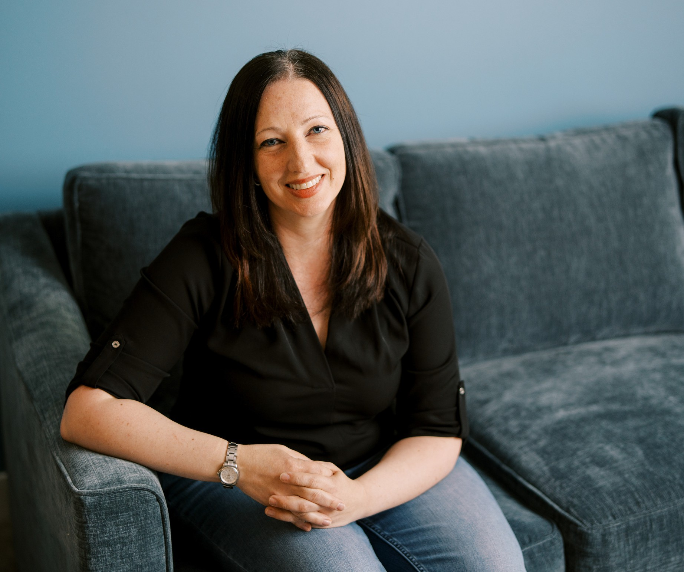
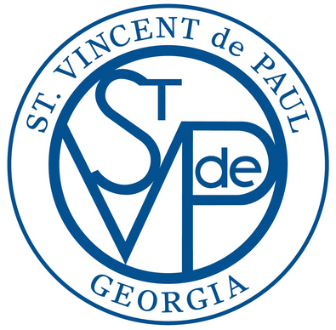
www.svdpgeorgia.org Assistance Line: 678-892-6163
St. Vincent de Paul Georgia has been providing Help and Hope to neighbors in need since 1903.

Love your Neighbor Live Vincentian
ST. VINCENT DE PAUL AT
ST. ANDREW CATHOLIC CHURCH, ROSWELL

Number of Members: 34
Neighbors Assisted in 2023: 461
Value of Annual Assistance: $104,000
Greatest Needs of the Conference: Our Conference is a diverse and dynamic, yet small community of Vincentians. Our greatest need is more hands on deck! We invite you to join us and learn what it means to Live Vincentian!

Available Roles:
Intake
Caseworker
Secondary Caseworker/home visitor Recruiting Officer
Pantry Coordinator

Holiday Projects Coordinator Database support
Other support roles are welcome, based on your experience and interest!

Meeting Times: 1st and 3rd Thursdays of each month, 7pm at the Upper Room in the parish

Conference President:
Christa Frye, ChristaFrye1@yahoo.com
Parish Info: St. Andrew Catholic Church 675 Riverside Rd. Roswell, GA 30075
770-641-9720
www.standrewcatholic.org

New Membership Representative:
Lisa Regan, lisar7154@gmail.com

If you are seeking a way to grow closer to God through meaningful friendships and love of neighbor, scan the code to be connected to a parish conference and
learn what it means to Live Vincentian!

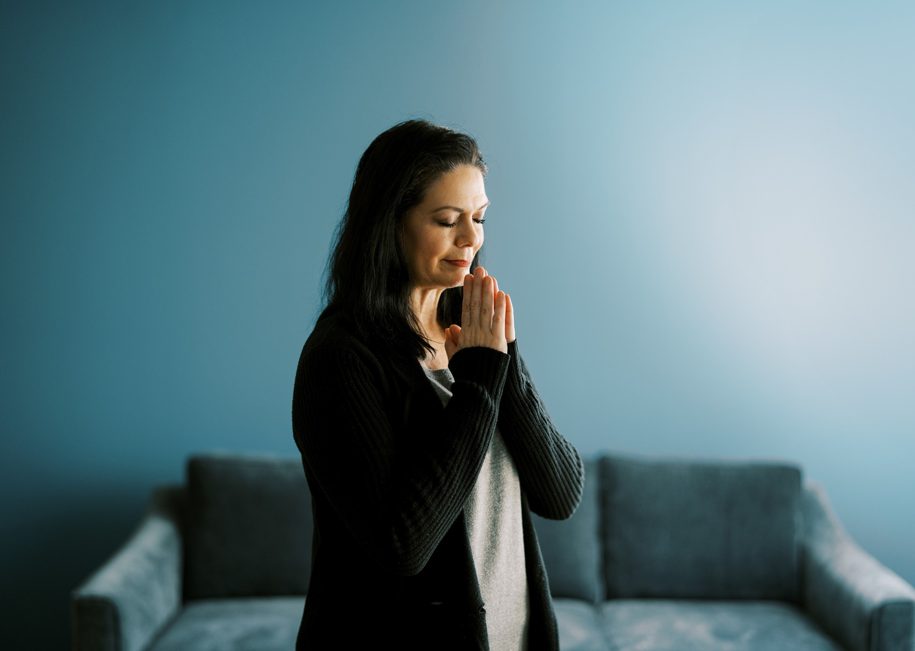
www.svdpgeorgia.org Assistance Line: 678-892-6163
St. Vincent de Paul Georgia has been providing help and hope to neighbors in need since 1903.

